[**XE125 Evaluation Board Product Brief**](https://www.mouser.com/datasheet/2/1126/XE125_Product_Brief-3133230.pdf)

**Power:**

The XE125 is powered via the USB connector J1 and/or via the pin header J8. The USB 5V power domain supplies the USB-UART chip (U2). If the USB-UART interface is not used, a dedicated USB

charger can be used.

The power pin header J8 provides the possibility to supply the XM125 module with power from

external power supplies. In Table 1, the pin assignment of J8 is shown:

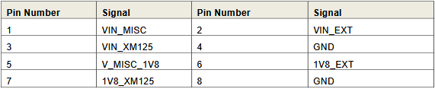

It seems like the best choice for use, due to both ease and modularity will be to power the device via the USB connector, either in parallel to the ESP-32 from our power supply, or the ESP-32.

**DATA:**

[Inter-Integrated Circuit (I2C) - ESP32-S3 - — ESP-IDF Programming Guide v5.4 documentation](https://docs.espressif.com/projects/esp-idf/en/stable/esp32s3/api-reference/peripherals/i2c.html)

Above is documentation regarding programming I2C on the ESP-32 S3, it’s pinouts are given in the datasheet from the adafruit:

[Pinouts | Adafruit ESP32-S3 Feather](https://learn.adafruit.com/adafruit-esp32-s3-feather/pinouts)

From this, it appears that SDA and SCL or the designated I2C connectors will be sufficient.



